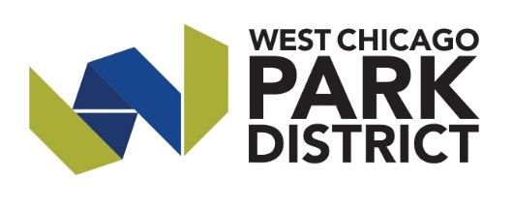**Press Release**

For Immediate Release

Contact Person

Danielle Spence, Marketing & Communications Manager

630.231.9474 or dspence@we-goparks.org

**West Chicago Park District Awarded Grant to Boost Community Tree Canopy**

West Chicago, Ill. 1/16/25 — The West Chicago Park District has been awarded a $299,911 subgrant by The Morton Arboretum’s Chicago Region Trees Initiative (CRTI) to improve the community tree canopy.

The competitive subgrant is among nearly 40 provided to nonprofits, government entities and other eligible groups through Inflation Reduction Act (IRA) funding to the U.S. Department of Agriculture (USDA) Forest Service, administered by CRTI.

The four-year grants, which do not require matching funds, are available for projects in communities that meet the federal requirements as disadvantaged. The funding can be used for projects that increase tree canopy, improve forest health, and create or enhance community forestry programs.

"We are thrilled to receive this grant, which will allow us to enhance West Chicago’s natural beauty and support the long-term planning and maintenance of our green spaces for generations to come. We invite residents to participate in the upcoming volunteer opportunities and educational sessions made possible through this grant. Together, we can create a healthier environment and vibrant spaces for everyone to enjoy. Thank you for your continued support in our vision!”

Through this subgrant, the West Chicago Park District will plant over 200 new trees, remove invasive species, prune and maintain both existing and newly planted trees, provide staff training, update the tree preservation ordinance, and develop a comprehensive forest management plan by 2028. For more details about the projects and timeline, please visit we-goparks.org.

Various projects funded through the CRTI sub-grants include tree planting and the formation of tree inventory and management plans, in both urban and rural areas, to help increase efficiency and proactiveness in community forestry, as well as support local economies and businesses through improved infrastructure and workforce development.

“Improving the distribution of trees and green spaces directly impacts the health and economic outcomes for communities,” said CRTI Director Zach Wirtz. “Projects like this improve quality of life and boost the urban tree canopy’s resilience to threats posed by environmental conditions, pests and diseases.”

Funding for this project provided by the Inflation Reduction Act and the USDA Forest Service, Urban and Community Forestry Program in partnership with The Morton Arboretum’s Chicago Region Trees Initiative. USDA, The Morton Arboretum, and the West Chicago Park District are equal opportunity providers.

**About the West Chicago Park District**

The West Chicago Park District was established in 1972 and since has been committed to creating an enhanced quality of life through effective programs, progressive facilities and preservation of parks and natural resources. The District maintains over 400 acres including Reed-Keppler Park known as "the heart of the community" that houses the state of the art ARC Center, TreeTop Escape, Turtle Splash Water Park, Toucan's Hideaway, splash pad, ZONE250, two dog parks, skate park, picnic shelters, multiple sports fields, playgrounds, bike trails, path system and a nature sanctuary.